 | QA/QC PROCEDURES MANUAL | Doc. Code : PM-OPN-2-
 | QA/QC PROCEDURES MANUAL | Rev. No. : 0
 | QA/QC PROCEDURES MANUAL | Eff. Date : Sept. 16, 2026
 | QA/QC PROCEDURES MANUAL | Pages : 1-6

Application Procedure — BLOCKOUT SAPAL RTU with PU (Method Statement)
Purpose: Provide a step-by-step procedures and quality controls for surface preparation, mixing, application, curing, inspection, and safety when installing BLOCKOUT SAPAL RTU (PU-acrylic vertical waterproofer) in accordance with Magna Prime Technical Data Sheet TD-RND-018 (Ver. 0.0, Mar 2024).

Scope
This method statement applies to vertical concrete, masonry, and previously coated exterior surfaces including balustrades, firewalls, parapet walls and concrete gutters where BLOCKOUT SAPAL RTU (Gray/White) is specified. It does not cover ponding or horizontal waterproofing applications.

References
- Magna Prime Technical Data Sheet: TD-RND-018, Ver. 0.0 (Mar 2024).
- BLOCKOUT SAPAL RTU product page (Magna Prime shop).
- Project drawings and specifications.

Materials, Tools & PPE
Item | Specification / Notes
Product | BLOCKOUT SAPAL RTU with PU. Packaging: 4 L and 16 L.
Coverage / Consumption | Theoretical: 0.15–0.25 L/m² per coat. System total: 0.45–1.25 L/m² (3–5 coats). Target DFT: 8–10 mils (200–250 µm). Volume solids: 45 ± 3%.
Application tools | Synthetic-bristle brushes, short/medium nap rollers, airless spray (recommended tip/spec per manufacturer's guidance), mixing paddle and drill, measuring cup for tinting.
Auxiliary materials | Reinforcing mesh/fabric for details, patching mortar for repairs, masking tape, drop sheets, clean water for cleaning.
Inspection tools | DFT gauge, wet-film comb (optional), moisture meter, tape measure, timer/clock, notebook or log sheet.
PPE | Gloves, safety glasses, dust mask/respirator (if sanding or grinding), long sleeves, safety shoes.

Pre-Application Checks
- Substrate cure and condition: New cast-in-place concrete must be cured for a minimum of 28 days. Verify no active structural movement or ongoing water ingress.
- Weather and site conditions: No rain for expected cure period; ambient and surface temperature within manufacturer limits. Do not apply when rain or dew is expected within the curing windows.
- Work area preparation: Protect adjacent finishes, glazing, metalwork and landscaping with masking and drop sheets. Provide safe access for applicators and inspection personnel.
- Product verification: Confirm product batch/lot, color, and TDS version (TD-RND-018). Record batch numbers in site records.

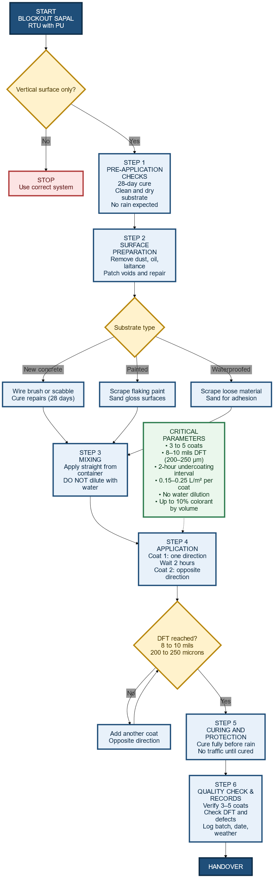
Surface Preparation
- Clean: Remove dust, dirt, laitance, efflorescence, oils, grease, mould release agents and any curing compounds. Use mechanical methods (wire brushing, scabbling, grinding) or approved detergents where necessary. Rinse and allow to dry.
- Remove unsound material: Chip out spalls, delaminated concrete, and weak zones. Prepare to sound substrate.
- Repair: Fill honeycombs, voids and damaged areas with a suitable cementitious or polymer-modified patching mortar. Allow repairs to cure per manufacturer's recommendations.
- Cracks and joints: Inspect cracks. Small hairline cracks may be bridged by the coating (product elongation >250%), but open or moving cracks must be routed and repaired or treated with appropriate sealants or reinforcing mesh embedded in the first coat. Prepare control/expansion joints for proper termination or provide flashing/termination details.
- Previously coated surfaces: Remove all loose or flaking coatings. Sand glossy surfaces to a dull profile. Test adhesion on a small trial patch.
- Moisture condition: This product’s TDS specifies application to clean, dry substrates. Confirm substrate is dry and free of rising moisture. If damp conditions are suspected, consult Magna Prime technical representative.
- Masking and protection: Mask adjacent surfaces, fixtures, windows and flashings to prevent contamination. Place drop sheets to catch spills.

Mixing and Tinting
- Ready-to-use: Do not dilute. The product is supplied ready-to-use. Do not add water.
- Stirring: Mechanically stir with a clean mixing paddle until homogeneous and uniform in color. Avoid entraining excessive air.
- Tinting: If tinting is required, add colorant up to a maximum of 10% by volume per the TDS. Tint uniformly across whole packs to avoid shade variation. Record tint percentage and colorant batch in site records.
- Batch control: For large areas, mix and apply product from the same batch or intermix (box) multiple packs to ensure consistent shade and finish.

Application Procedure
- Application methods: Apply by brush, roller, or airless spray. When spraying, back-roll or brush to ensure full film continuity and to remove possible pinholes. Use suitable spray equipment and tip size per applicator guidance.
- First coat: Apply a full, even first coat in one direction. Work in manageable areas and maintain a wet edge to avoid lap marks.
- Subsequent coats: Allow the specified undercoating interval. TDS undercoating interval: 2 hours (typical). Allow longer drying under cool/humid conditions or if film appears tacky. Apply second coat crosswise (perpendicular to the first) to improve coverage and minimize pinholes. Continue to apply coats until system requirements are met.
- Number of coats and DFT: Apply 3–5 coats until an accumulated dry film thickness (DFT) of 8–10 mils (200–250 µm) is achieved. Verify with a DFT gauge. Do not attempt to reach required DFT in a single heavy coat.
- Reinforcement at details: At corners, junctions, parapet terminations, and over repaired cracks, embed recommended reinforcing mesh into the first wet coat. Once embedded and still wet, apply the next coat to fully encapsulate the mesh.
- Terminations and flashing: Flash coat terminations onto caps and adjacent vertical surfaces to create proper shedding. Provide sealant termination at movement joints per project detail.
- Wet edge / workability: Maintain a continuous wet edge and avoid reworking partially cured areas. If overlaps occur, abrade and recoat as required to achieve continuity.

Drying, Curing and Protection
- Drying: Typical drying time: 2–4 hours depending on film thickness, temperature and humidity. Use longer intervals in cool or humid conditions.
- Curing: Allow full cure per TDS before exposure to rain, ponding water or foot traffic. Protect area from rain and other contamination during cure.
- Protection: Do not permit foot traffic, staging or loading until the coating has achieved the required cure. Remove masking and drop sheets only after the coating is sufficiently tack-free to avoid damage. Clean tools and equipment with water immediately after use.

Inspection, Testing and Acceptance Criteria
- Visual inspection: Ensure full, uniform coverage with no holidays, pinholes, blistering, runs, sags, or thin spots. Recoat or repair defects immediately.
- DFT measurement: Verify the completed system reaches 8–10 mils (200–250 µm) DFT across typical areas. Record measurements and locations.
- Adhesion and test panel: Where substrate or existing coatings are uncertain, prepare a test patch/panel to confirm adhesion and appearance prior to full-scale application. Document results.
- Moisture/Leak test: If required by project, perform a water test (controlled ponding or hose test per specification) after full cure to check for leaks or dampness.
- Records: Maintain a site log that records product name and TDS version (TD-RND-018), batch/lot numbers, tint percentage, application dates/times, coat counts, DFT readings, ambient conditions (temperature, RH), applicator names and inspector sign-off.

Common Defects and Prevention
Defect | Likely Cause | Preventive Action
Blistering or peeling | Moisture in substrate; rain during cure; uncured new concrete | Confirm 28-day concrete cure; apply to dry substrate; avoid rain during cure; allow correct drying intervals.
Pinholes / holidays | Insufficient coats; poor application technique or spraying without back-rolling | Apply 3–5 coats; crosswise application; back-roll after spraying to ensure film continuity.
Poor adhesion | Contamination (oil, laitance), unsound substrate, or glossy old coatings | Thorough surface preparation: remove laitance, clean, sand glossy surfaces, and perform adhesion test patch.
Color inconsistency | Tint variation between packs | Tint by lot or intermix packs; record tint percentage and batch numbers.
Cracking reappears | Movement in substrate beyond coating capability; insufficient thickness | Repair active joints; embed reinforcement in details; achieve required DFT of 200–250 µm.

Health, Safety and Environmental Controls
- PPE: Use gloves, eye protection and appropriate respiratory protection when sanding, grinding or spraying.
- Ventilation: Provide ventilation in enclosed or partially enclosed spaces. Use extraction where needed.
- Waste handling: Collect wash water and residues; do not discharge into storm drains. Dispose of empty containers and residual product in accordance with local regulations and SDS guidance.
- Emergency: Have eye wash and first aid ready. Refer to product SDS for first aid measures.

Documentation and Handover
- Site records: Submit the application log, DFT readings, batch/tint records, and test panel photographs to the client or project QA.
- TDS and SDS: Include copies of the product Technical Data Sheet (TD-RND-018) and Safety Data Sheet with the handover pack.
- Maintenance guidance: Provide owner with simple maintenance guidance: inspect annually, repair local defects promptly, avoid abrasive cleaning, and contact Magna Prime for guidance on major repairs.

13. APPENDICES

Service Agreement

PM-OPN-02-16 Painting Works Checklist form

Billing form

